**Introduction:**

To know which factor may affect the student's performance, we classify the score into couple of ranks, and figure out which feature affects the score more significant. The independent variables are followed:

1. gender: sex of students
2. race/ethnicity: ethnicity of students
3. parental level of education: parents' final education
4. lunch: having lunch before test (normal or abnormal)
5. test preparation course: complete or not complete before test

**Content:**

Some column names are too long, rename the column names to be simpler.

Remove Null values and NaN from the dataset

**CODE(Snapshot):**

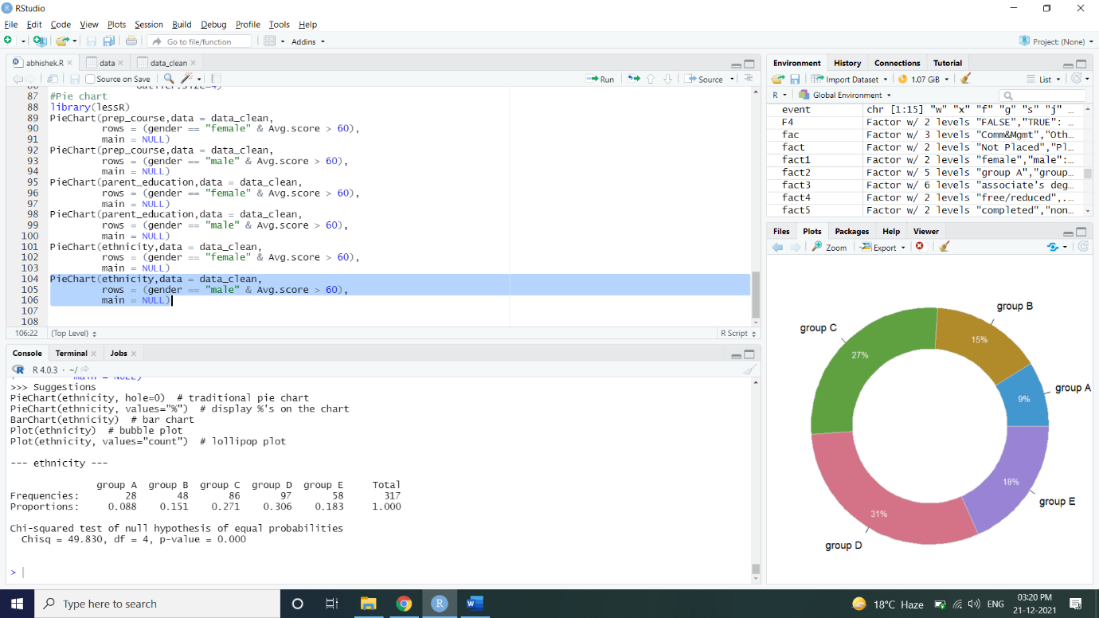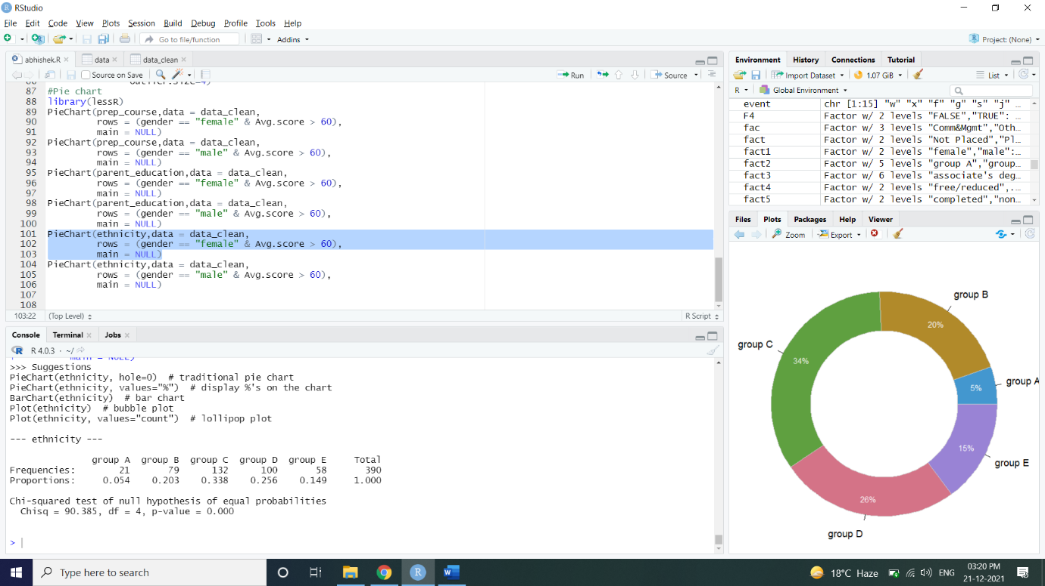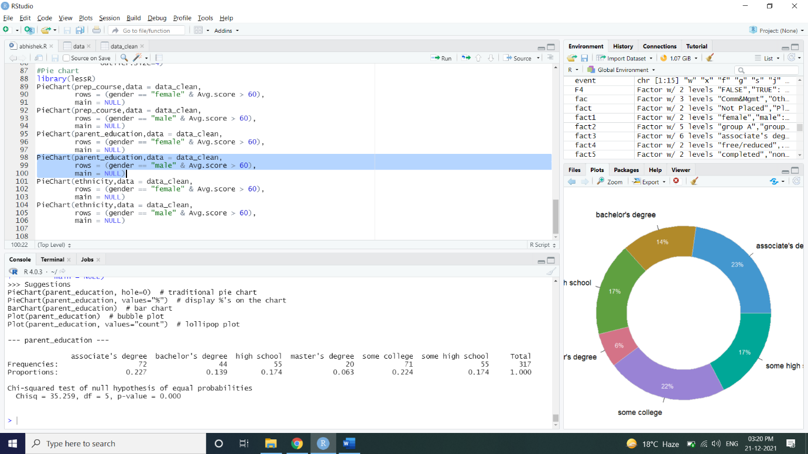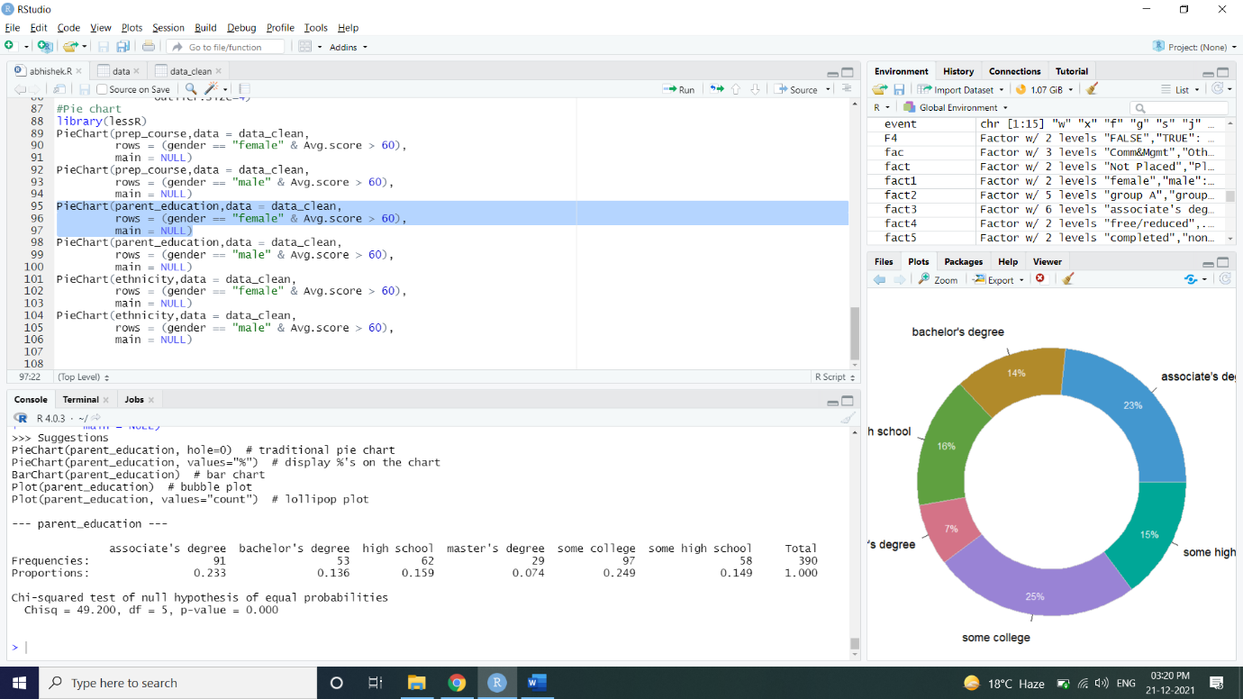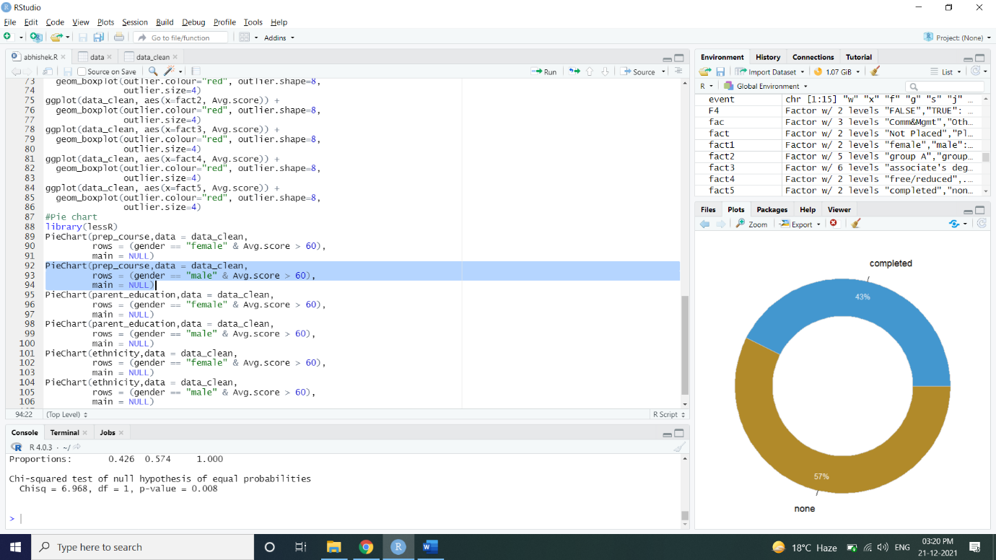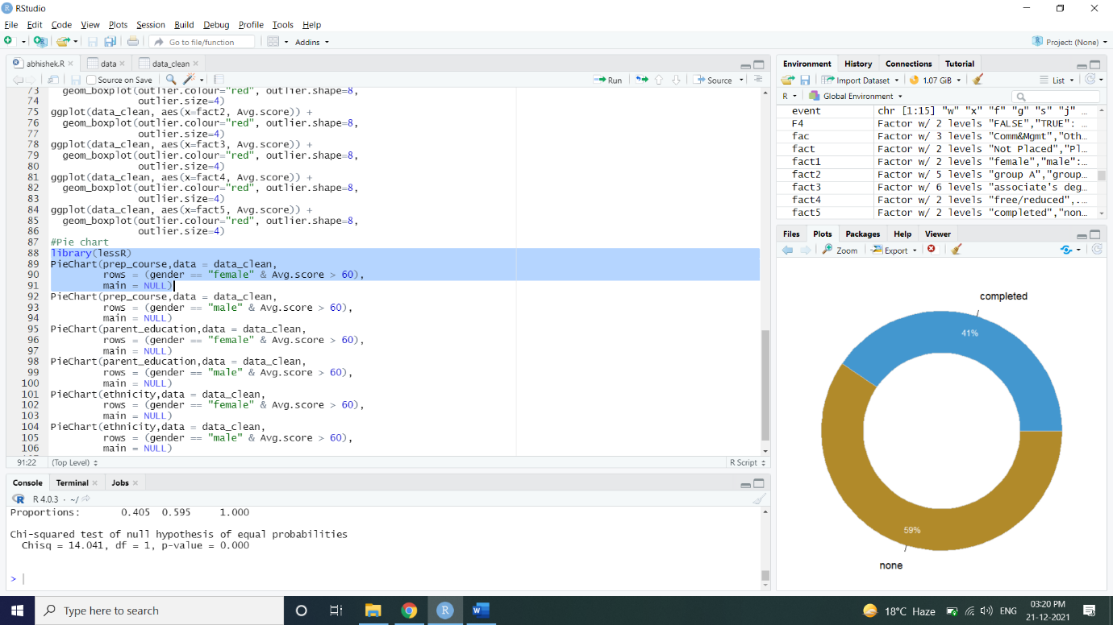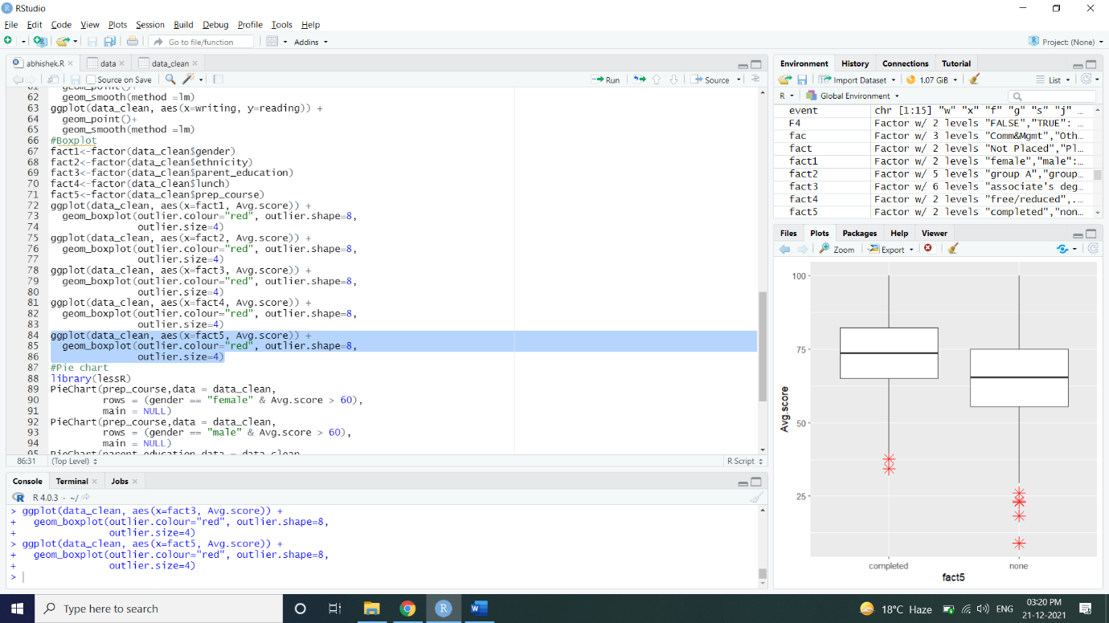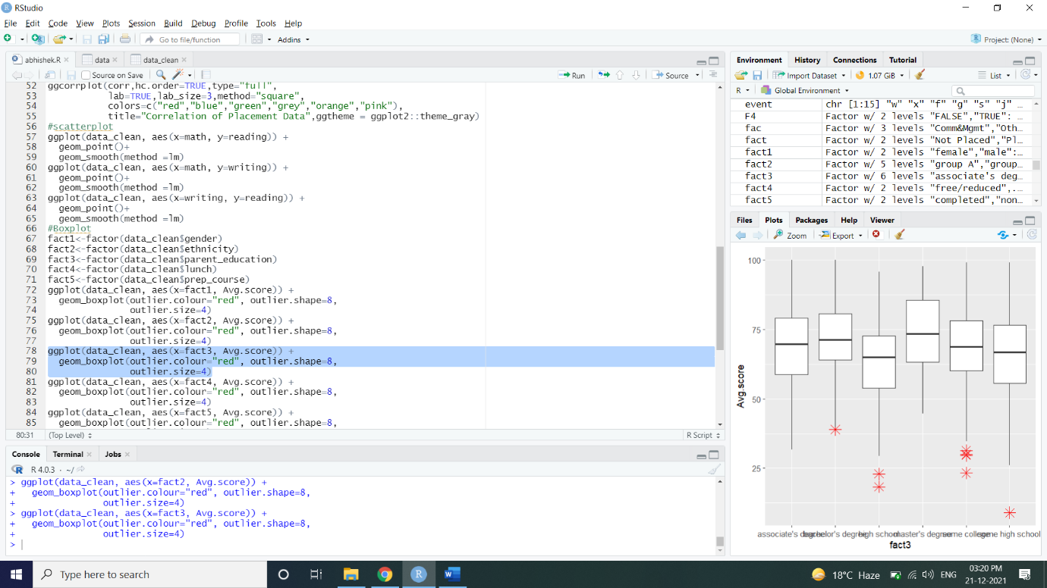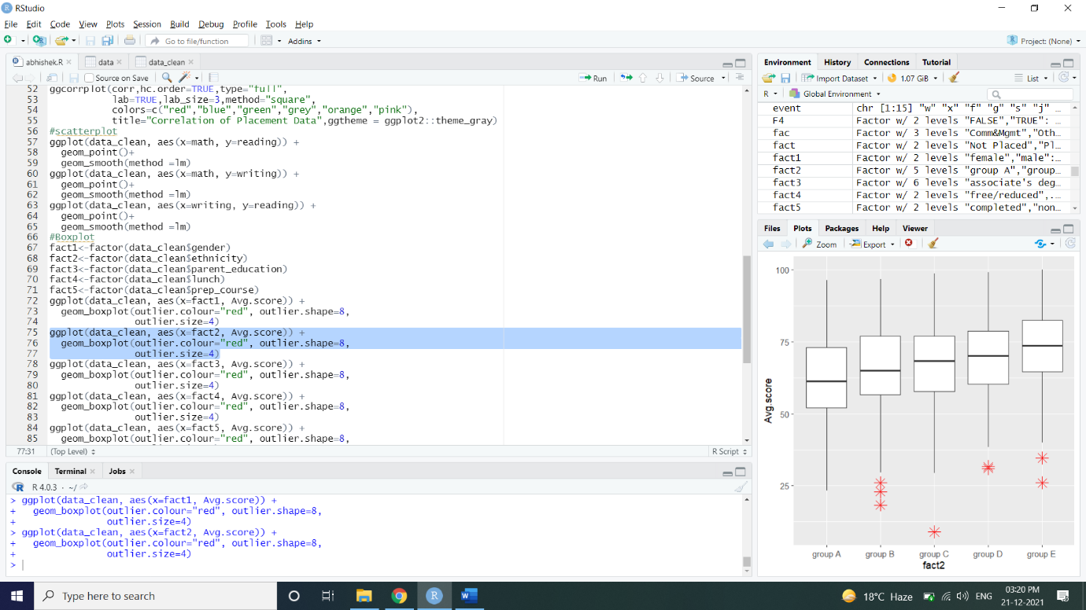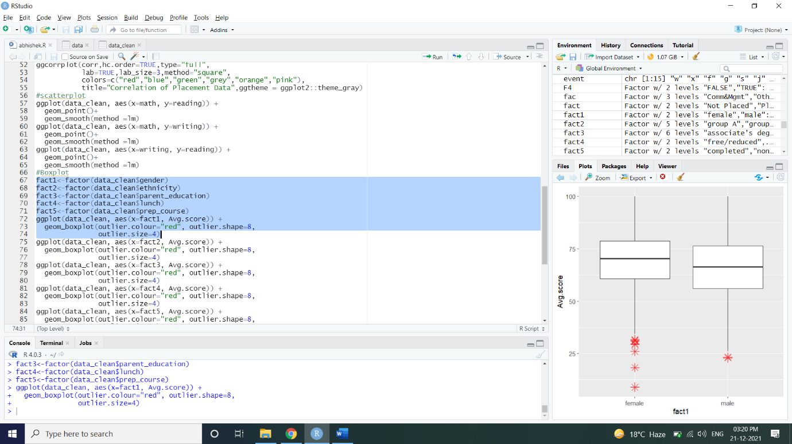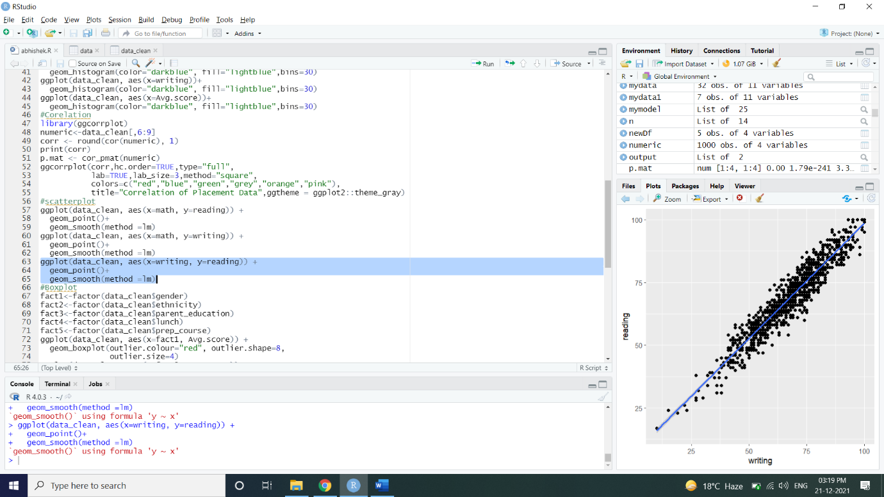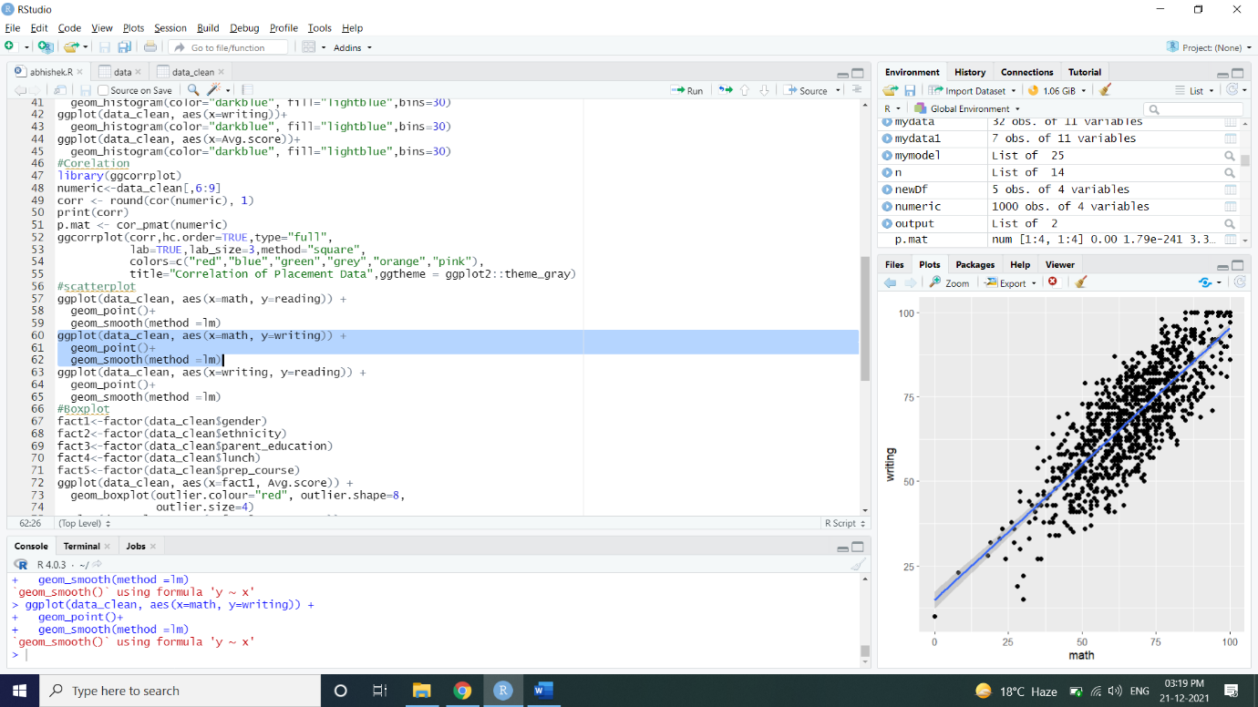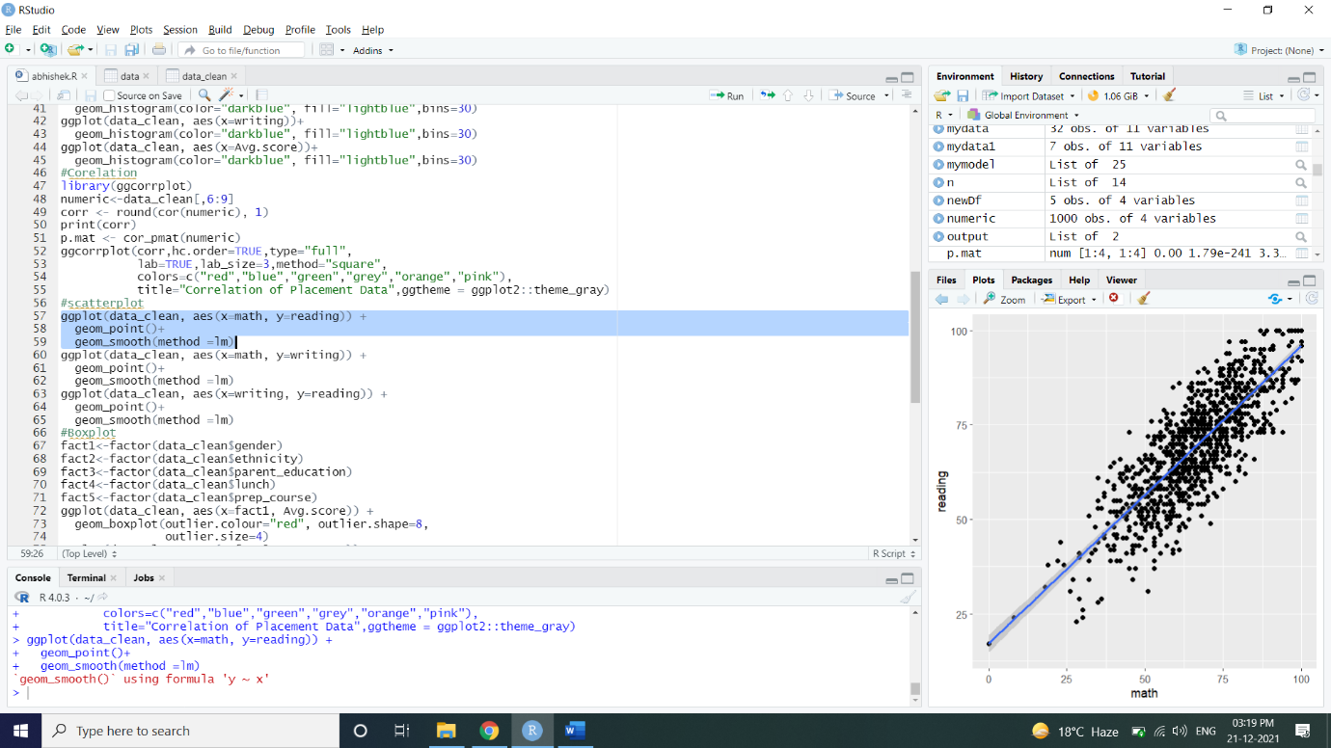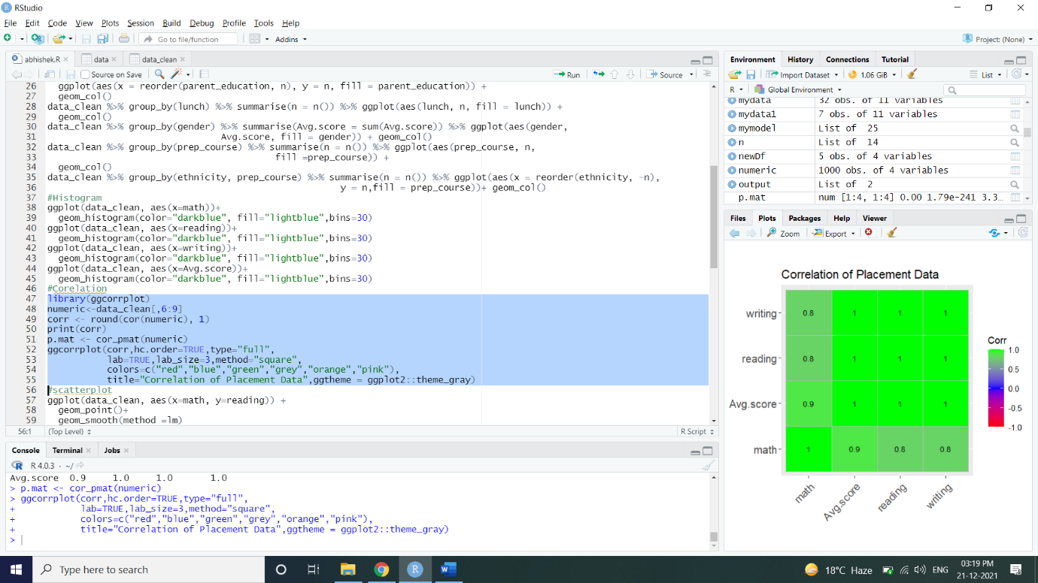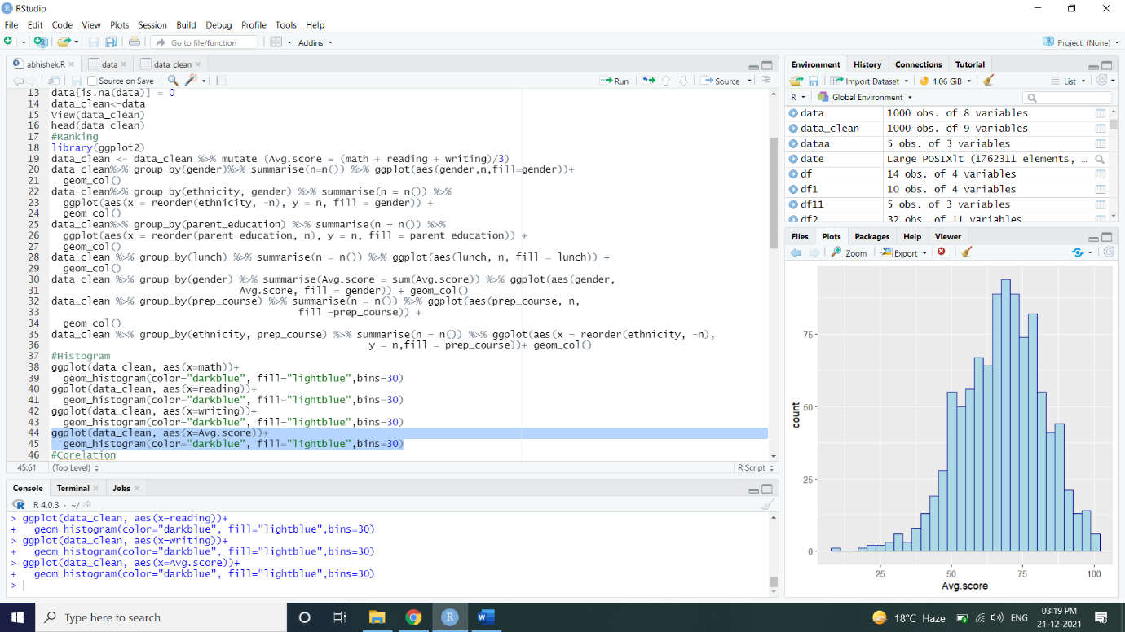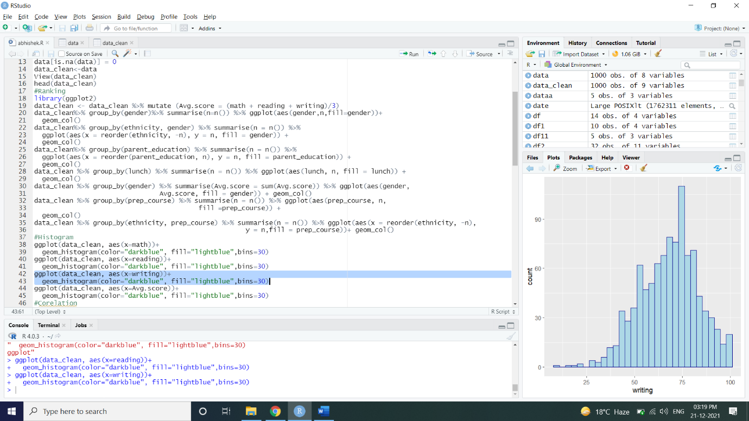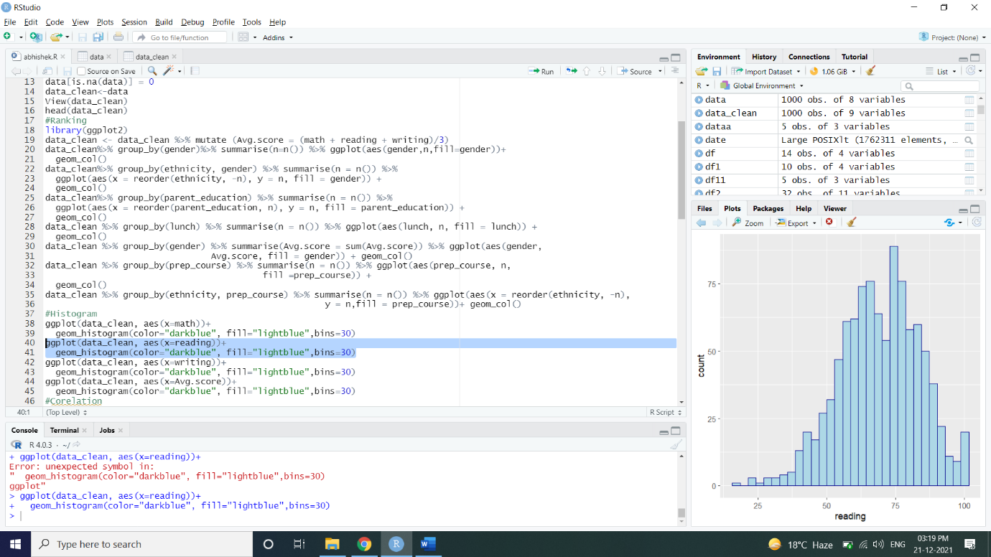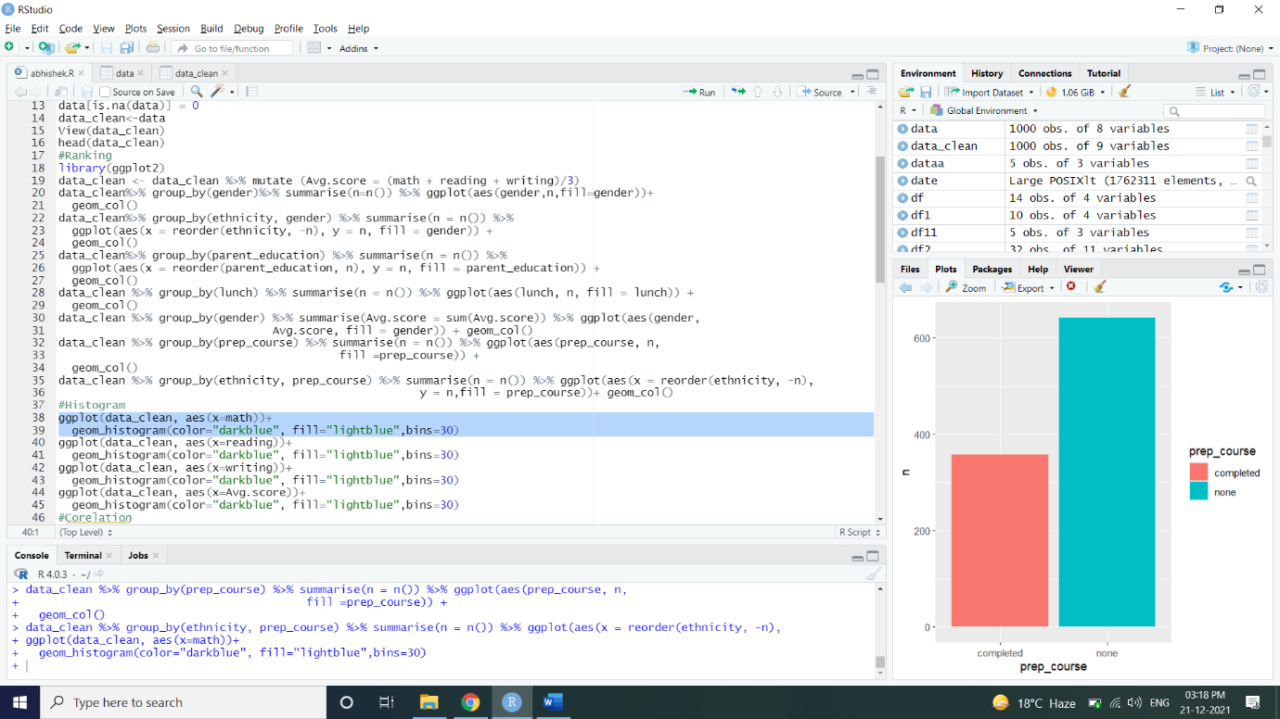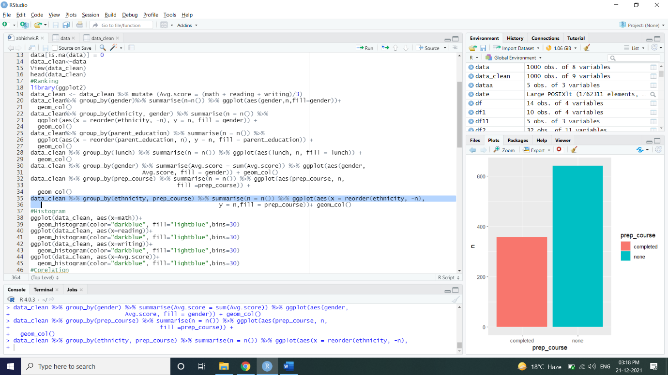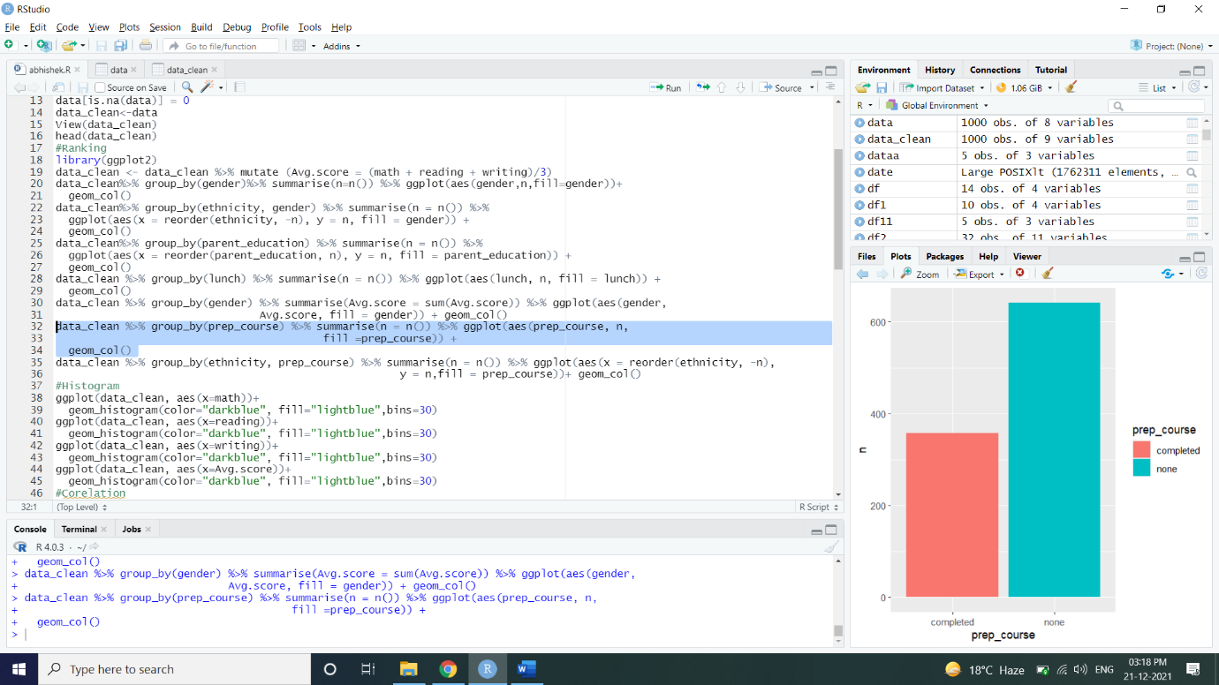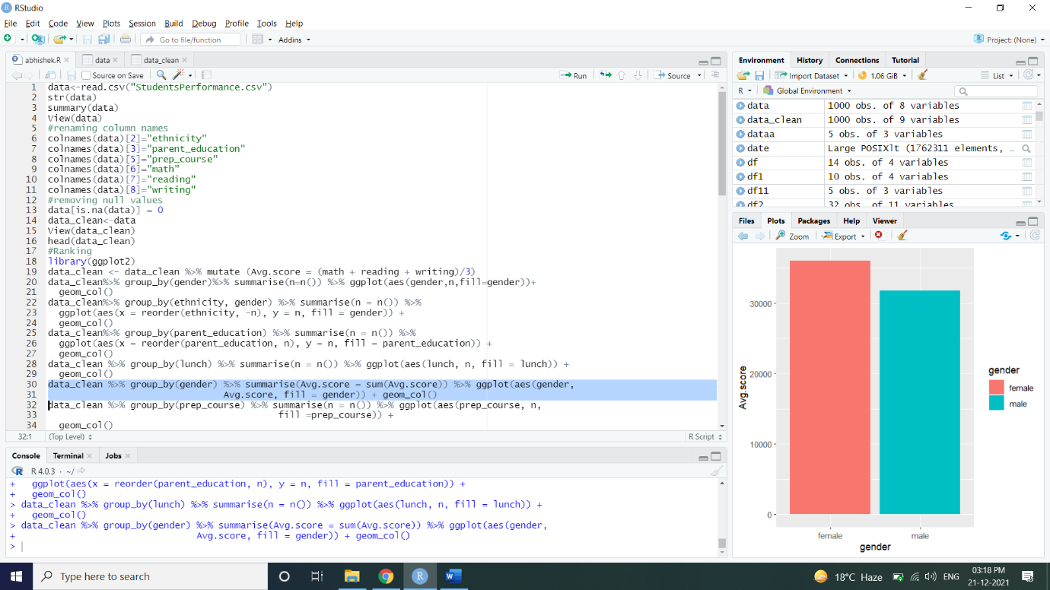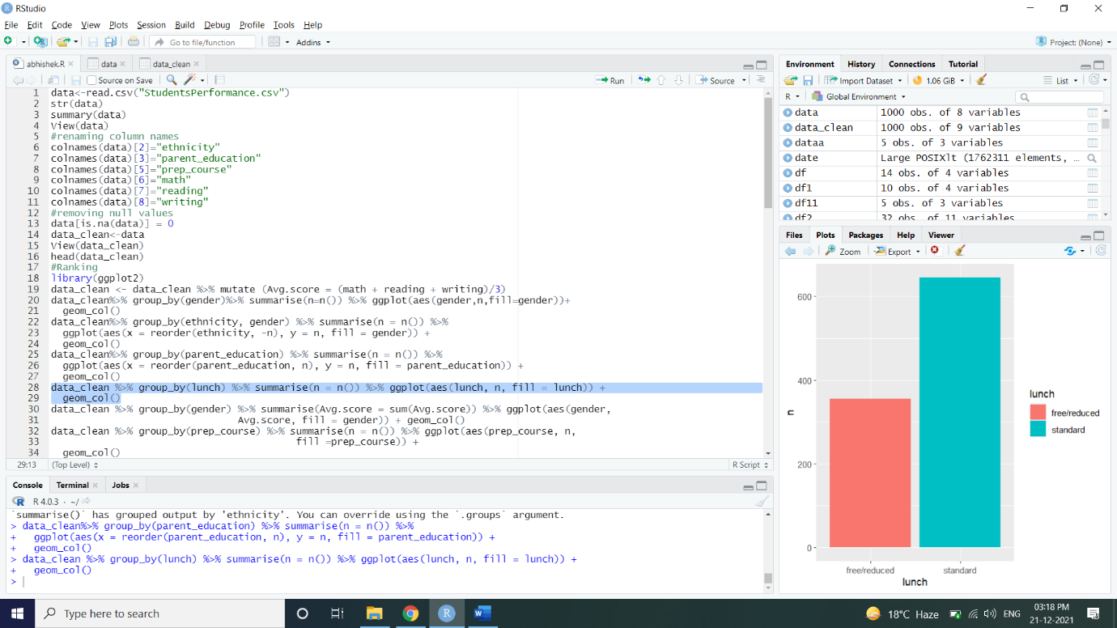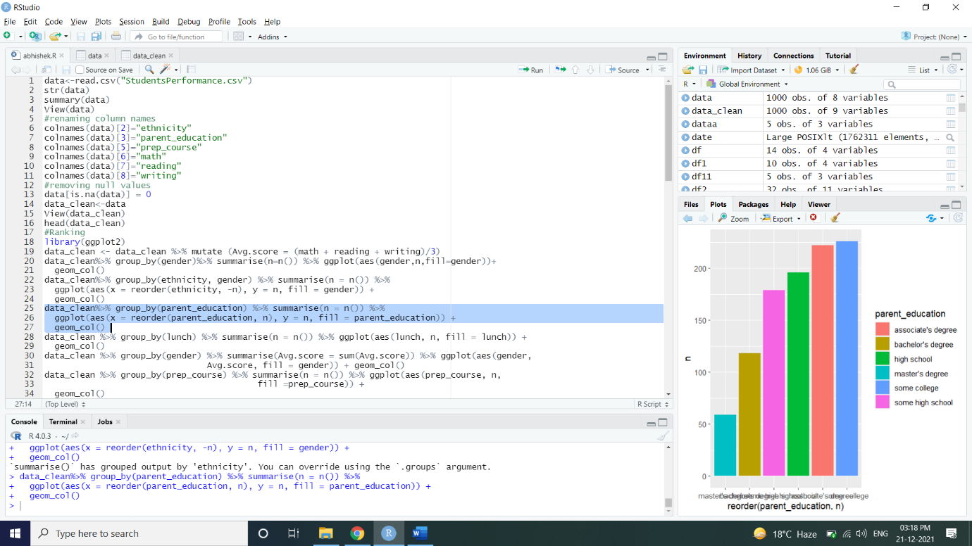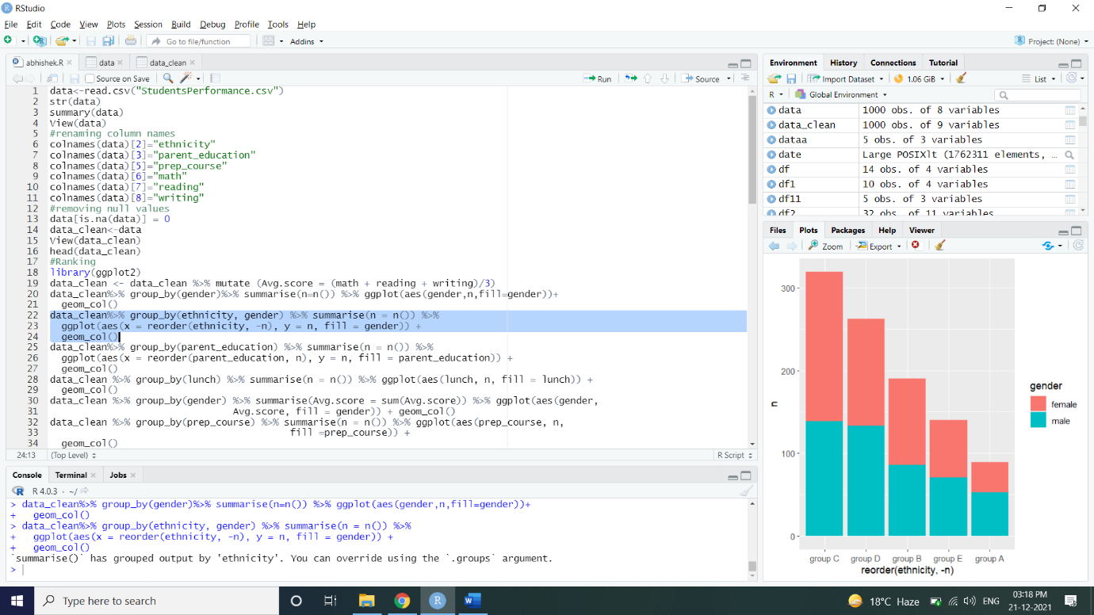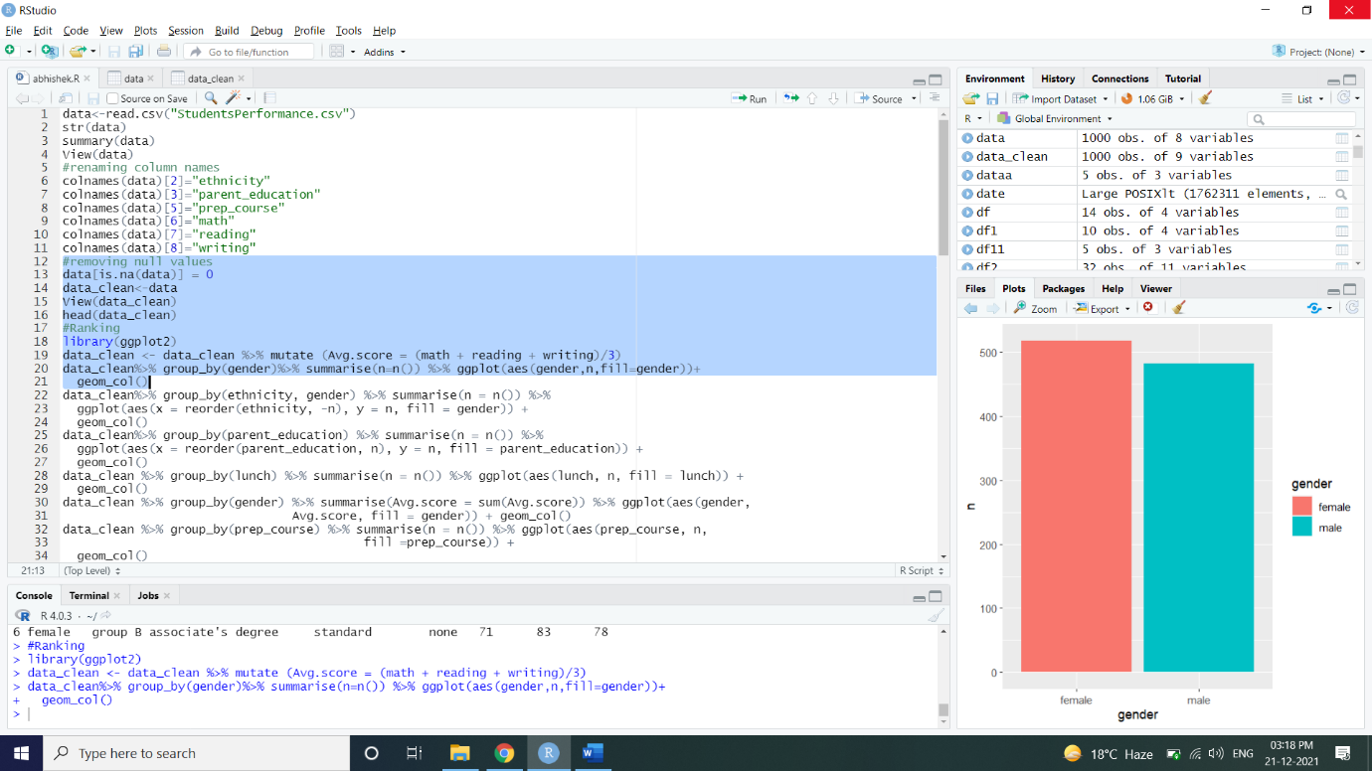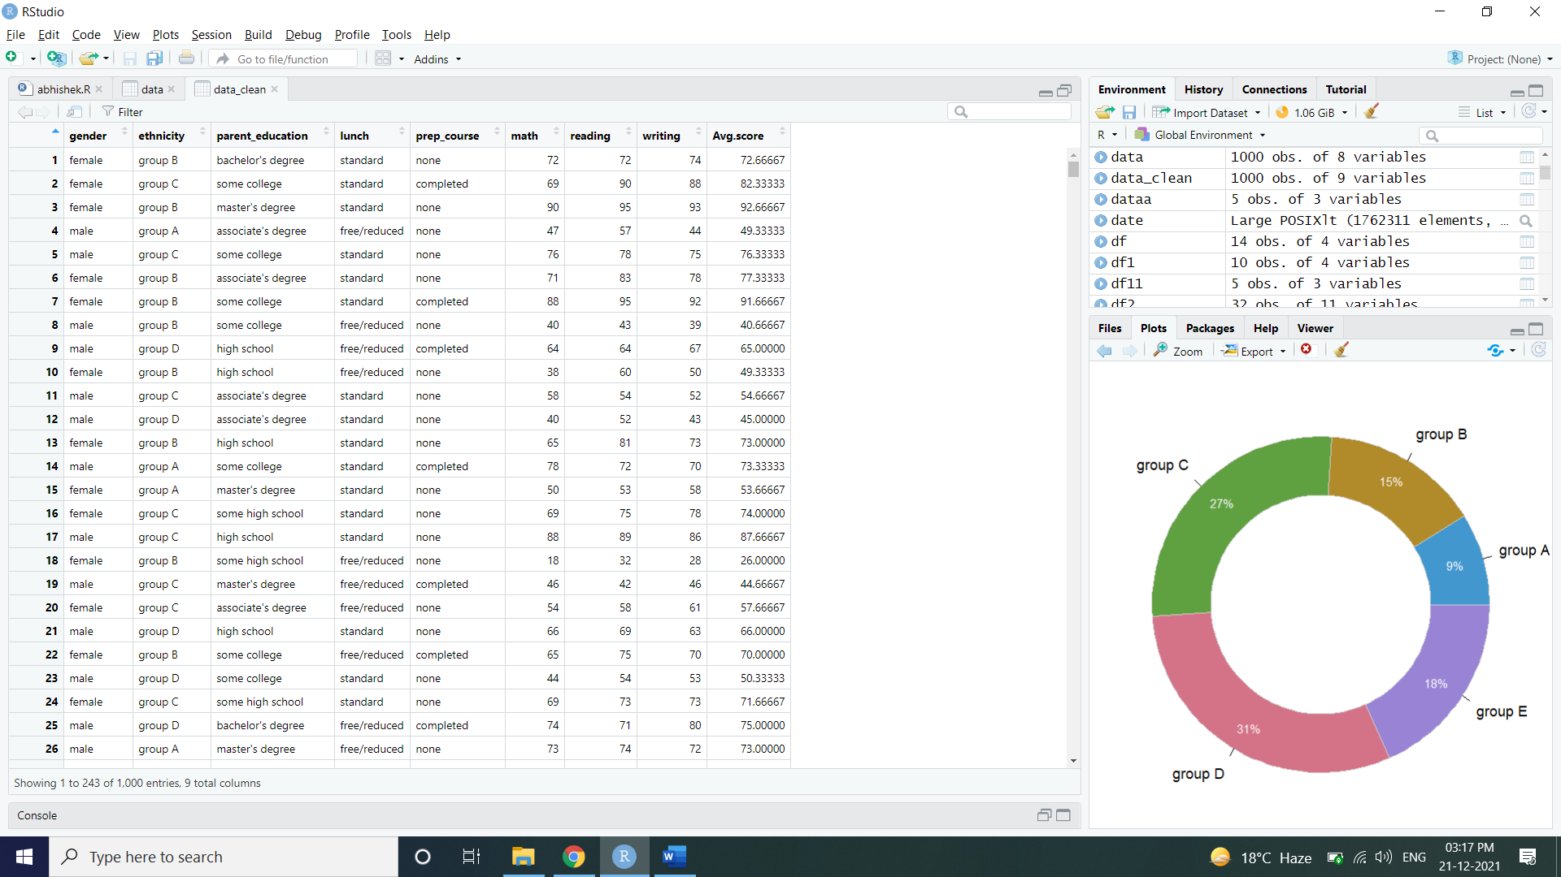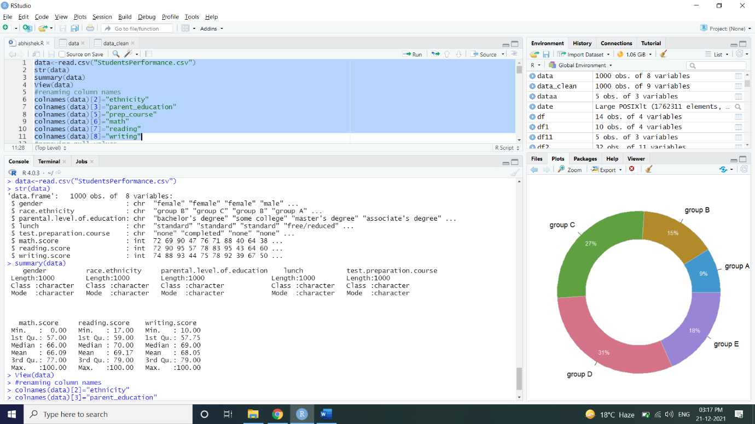

**Approach:** To predict the performance of students in the exams, with consideration of demographic and socioeconomic factors -

1. Exploring the Data: Checking how the variables are behaving and summarising.
2. Data Visualisation: To check how these variables are reacting individually and when put together.

Now, we can add the Average Score as the new variable in the data, as it would be more appropriate to check the students' performance.

**DATA VISUALISATION:**

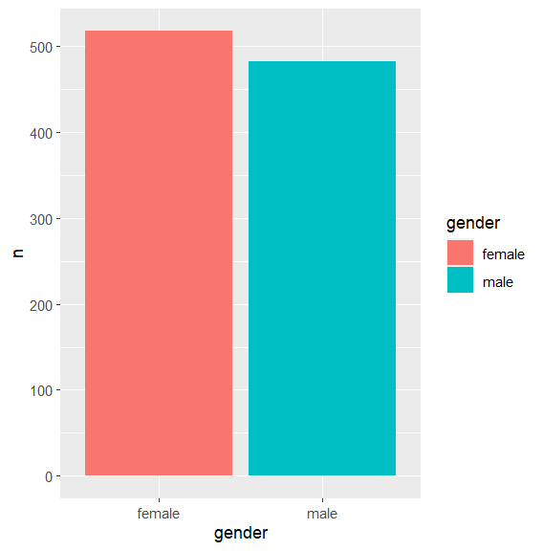

**In this graph, clearly shown that females are more than males in numbers**

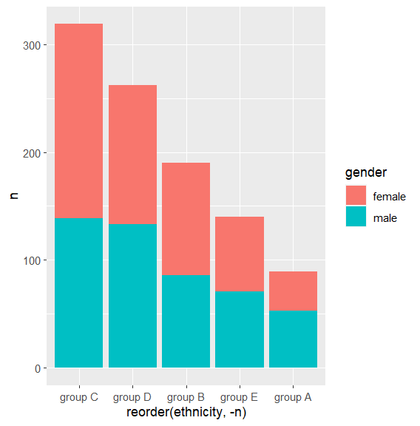

**Here, the population is divided unto demographic factors showing how many students are there from different communities on basis of gender**

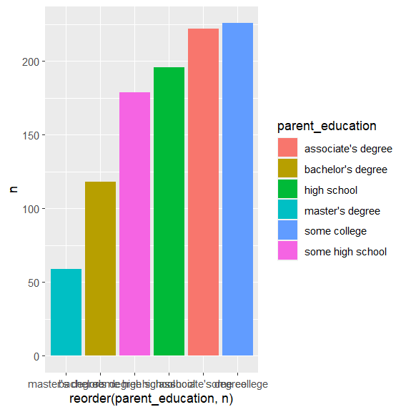

**It shows the different levels of education covered by the parents and majority of them have done high school and degree.**

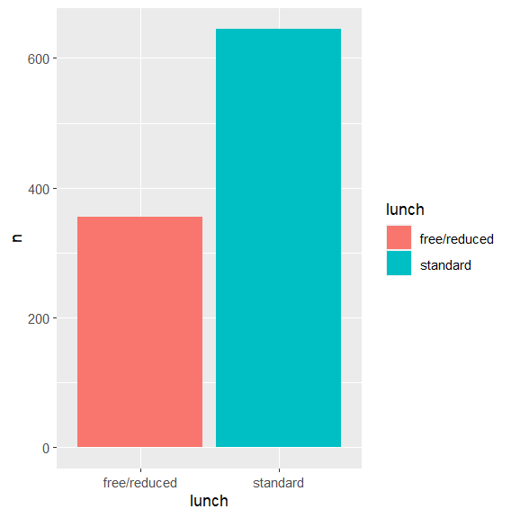

**Here, number of having standard lunch are more as compared to having free/reduced lunch**

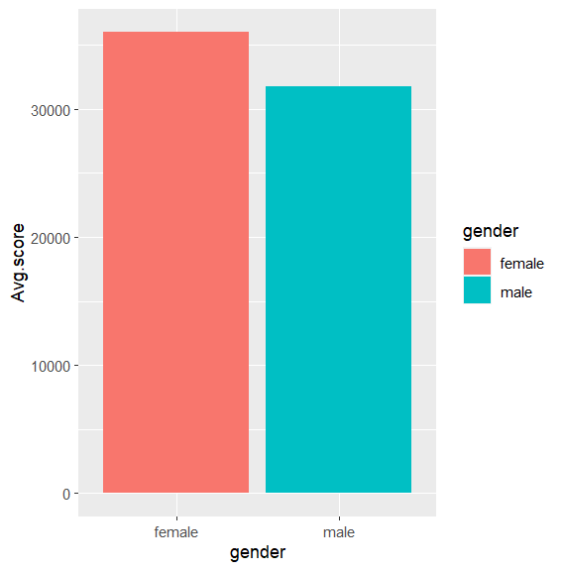

**Having more female population could have effect on the total average score of two different groups.**

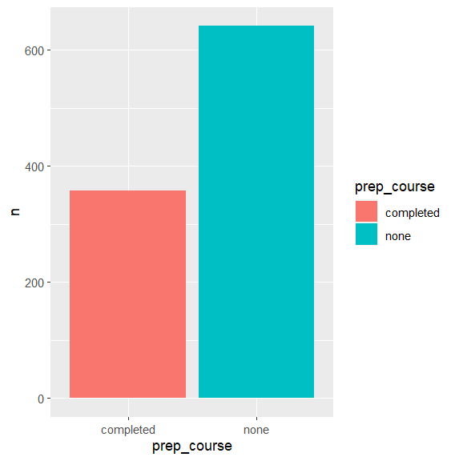

**Here, number of students opt for preparation course are less**

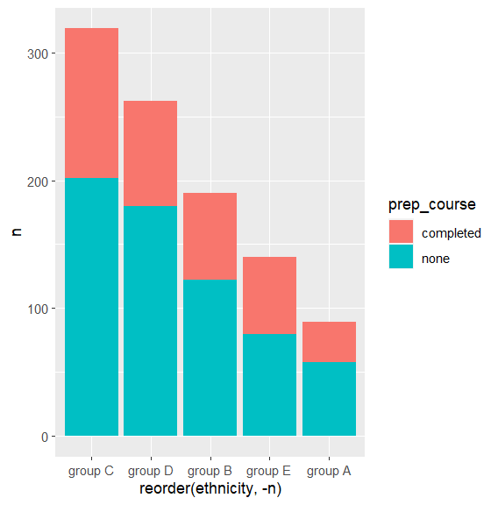

**Here, number of students opt for preparation course of Group A are less and In Group C number of students not opt for preparation course are more**

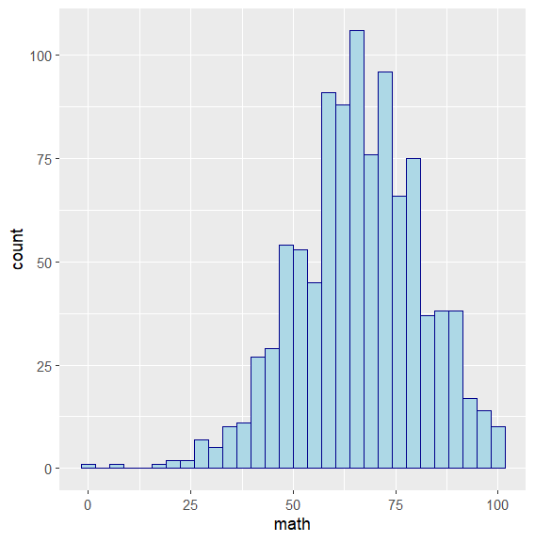

**More Students got marks between 60-70 in Math**

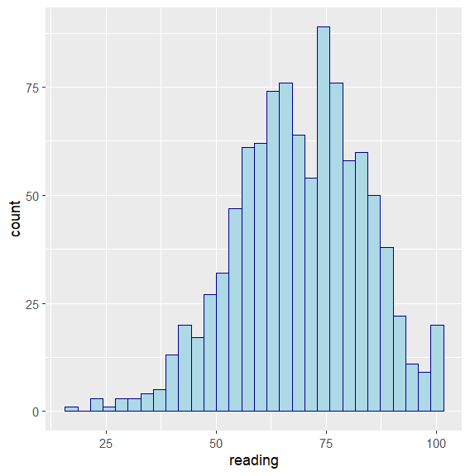

**More Students got marks between 60-70 in Reading**

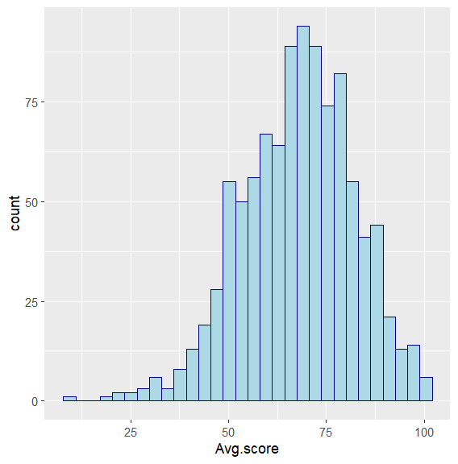

**More Students got marks between 60-70**

**The normal distribution can be used to know about the scores from the above histograms.**

**CORRELATION FOR THE SCORES:**

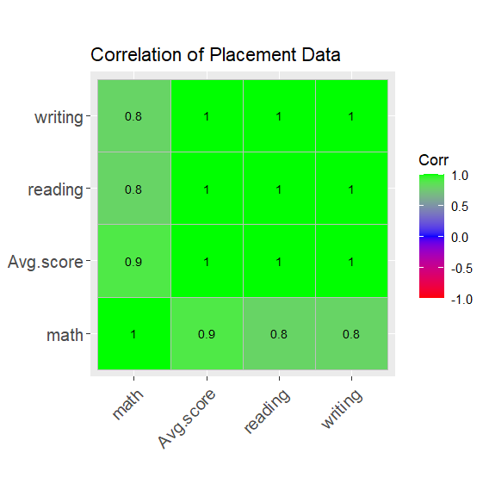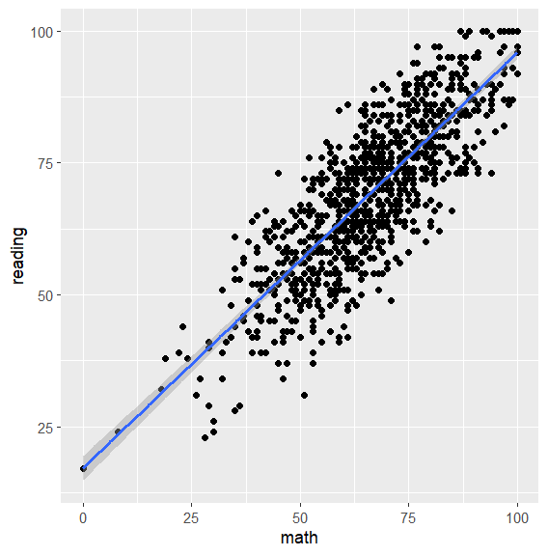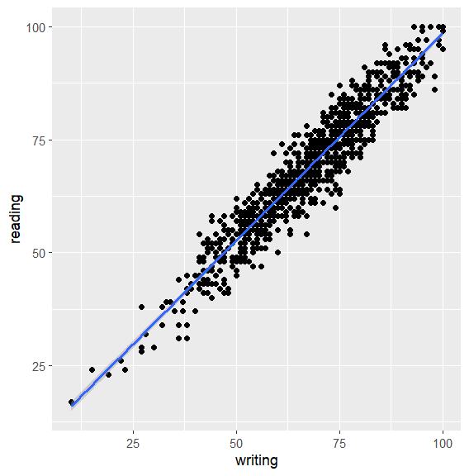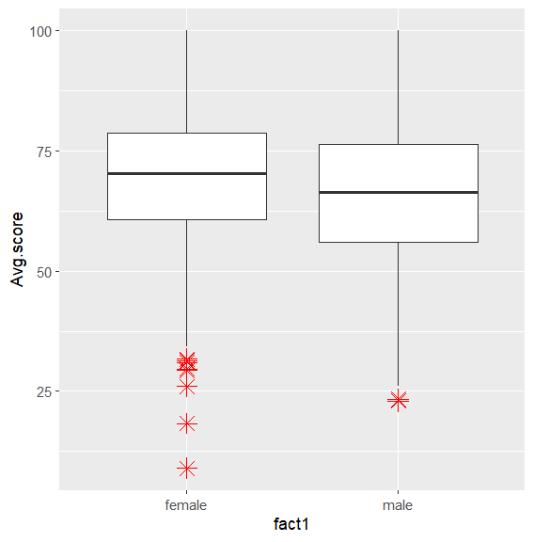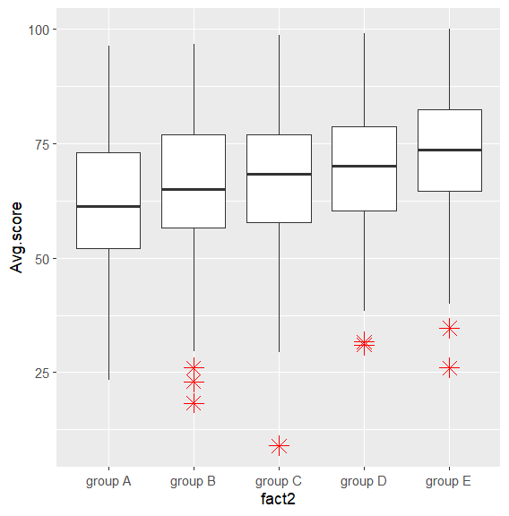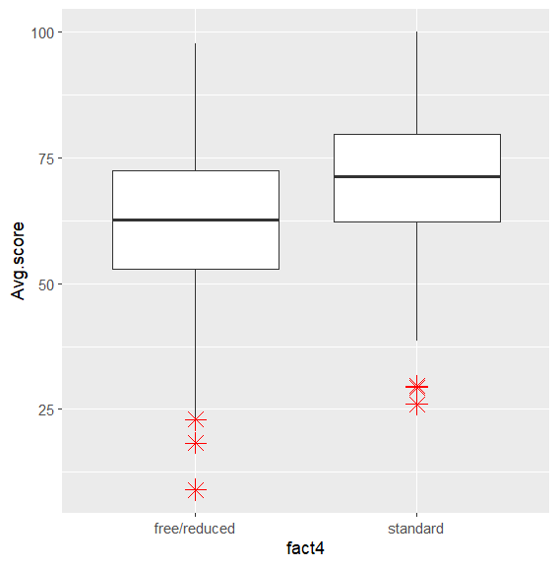

**SUMMARISING THE VISUALISATION:**

1. There are few more female students than the male.
2. The group C has the majority while the group A is a minority.
3. The major portion of parents have done some college for their education, however there are less parents with master's degree (>100).
4. Most of the students have standard lunch.
5. 2/3rd of the students didn't prepare for the test (approx.).
6. The Correlation between the reading and writing score is the highest.

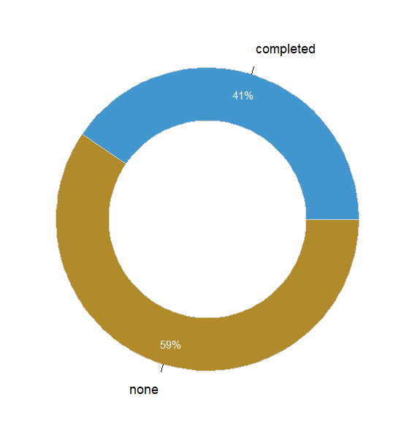

**Females opt for placement course or not whose average score is more than 60**

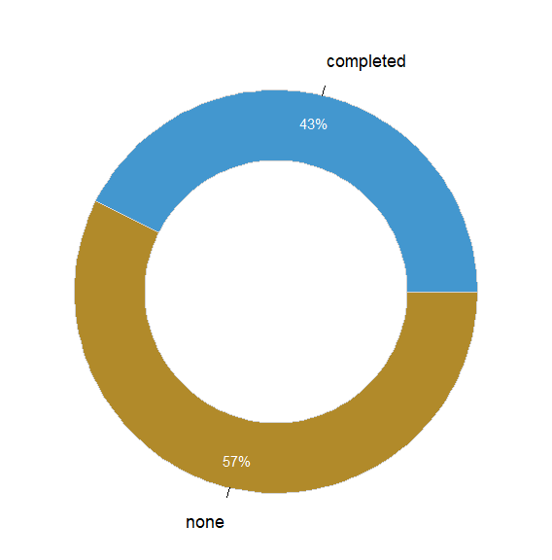

**Males opt for placement course or not whose average score is more than 60**

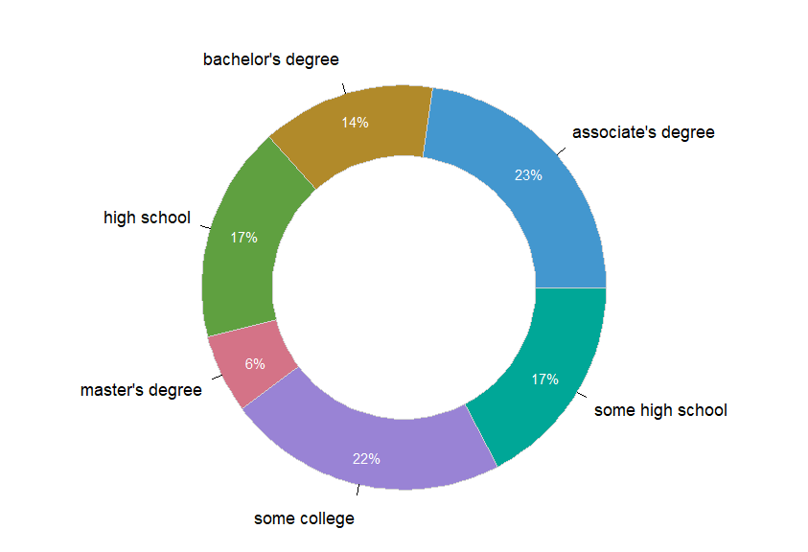

**Male’s parent education whose average score is more than 60**

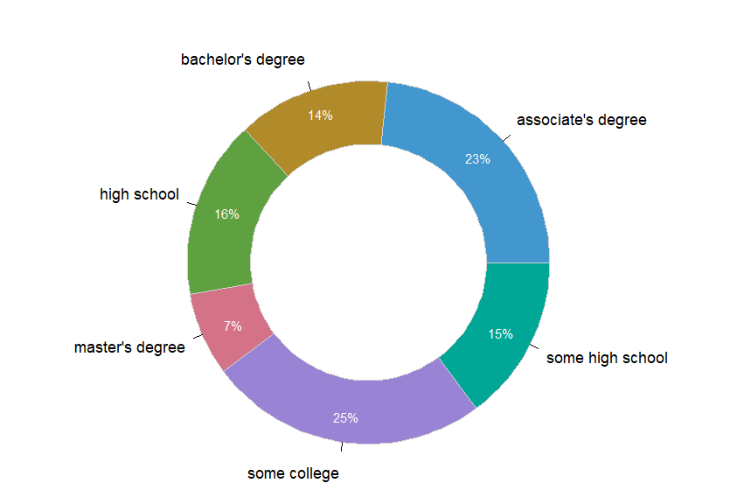

**Female’s parent education whose average score is more than 60**

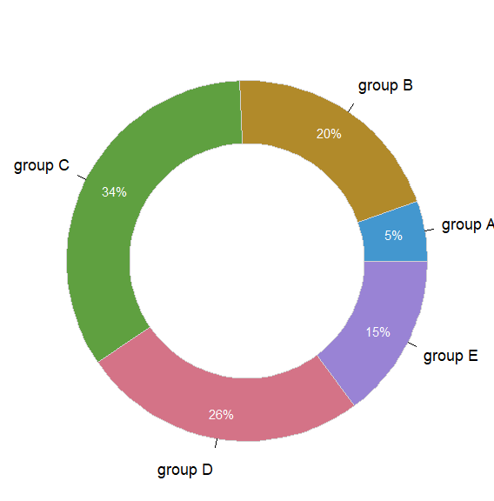

**Female’s ethnicity whose average score is more than 60**

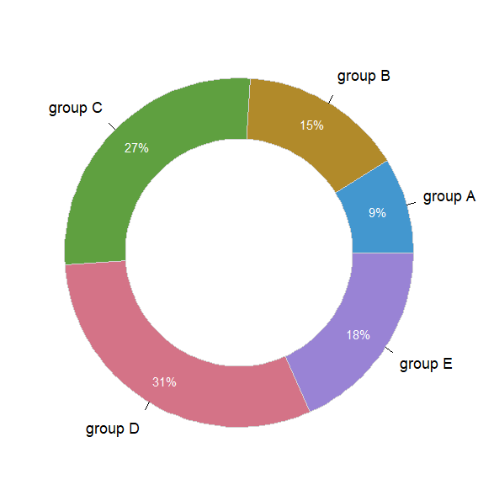

**Male’s ethnicity whose average score is more than 60**

**Conclusion:**

There are few conclusions below:

1. Parents' education level may affect the performance of students, but not the important one.
2. Finishing preparation course is beneficial.
3. Having lunch is important to students, and it is also the most significant one.
4. Gender has no correlation with the score.

In summary, if students want to have good performance, they should have enough nutrient and make effort to prepare the test.